Boyd Gibson (Student)

User Guide

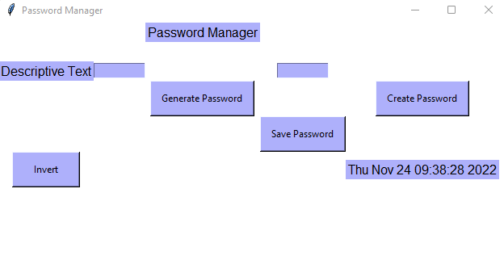

* When you load up the interface the first thing you should do is select the Invert button
* 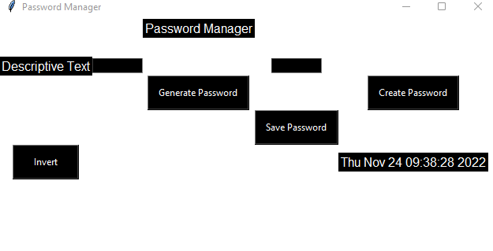Some users prefer this as they find it easier to read.
* If you fell that you would prefer the other color scheme, then you can select the button again to change it back

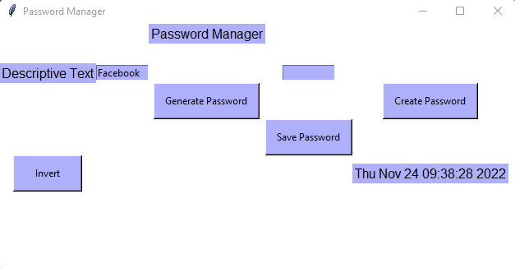

* Once you have selected the color scheme you should enter the name of what your password is to be used for in the text box next to the label Descriptive Text

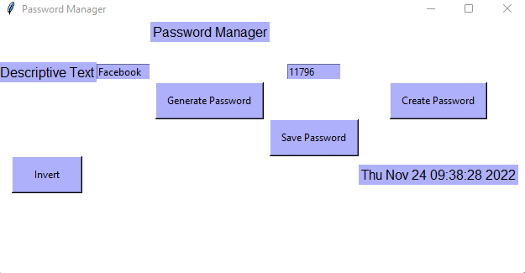

* From there you should select either the Generate or Create Password button
* In this case I have selected the Generate Password button
* The password Generated was 83865720

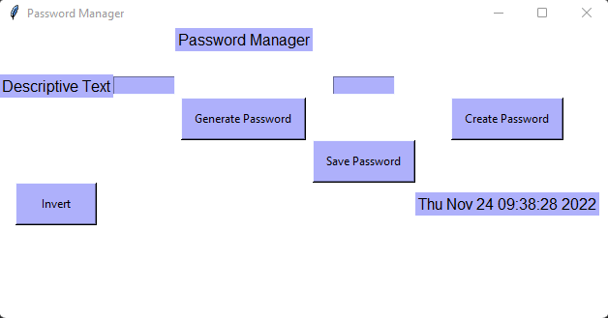

-Once you have entered the descriptive text and generated your password the final step is to click the Save Password Button which will clear both text boxes and save you password.

* 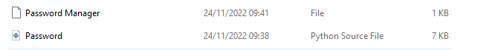Upon doing this for the first time the Password Manager text file will be created in the same place that the program is saved.

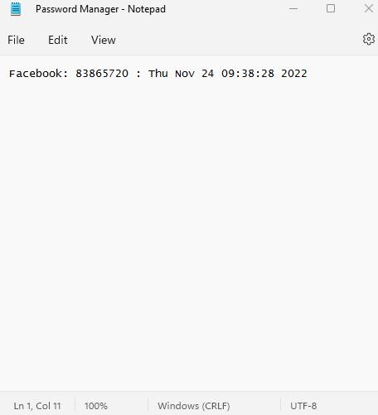

* As you can see the descriptive text, the generated password and the date and time upon creating have been saved in the text file for you to use as and when you need to.

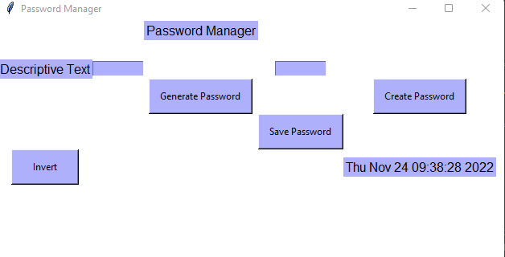

* If you want to Create your own password
* You simply enter the descriptive text again
* But this time you select the Create Password Button and enter your password in the text box above
* 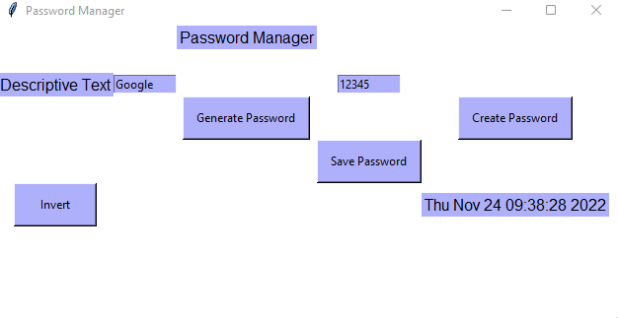From here you once again click the Save Password Button which will save both the entered descriptive text and now Created Password

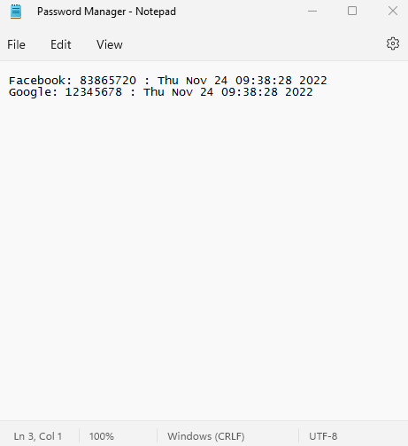

* And again, the text, password and Date time have been saved to the Password Manager Text File